 | Supplementary material for  Castells Navarro, L., S. Metz, M. Bleasdale, J. Evans, M. Legge, L. Büster, D. Reich & I. Armit. 2026. Reconnecting the dead in Iron Age Britain: funerary processing and long-distance connectivity at Loch Borralie, Scotland. Antiquity 100.  Author for correspondence: Laura Castells Navarro ✉ laura.castellsnavarro@york.ac.uk

Human osteology: technical report
Introduction
This report is the osteological analysis conducted for the skeletal remains of two individuals found at Loch Borralie, Sutherland, Scotland: Individual 1 and Individual 2.
Methods
The overall cortical surface preservation was evaluated using the seven-stage gradient system developed for human remains (McKinley 2004) and completeness of the remains was recorded as a % estimation of the individual bone as well as the skeleton, using a four-stage system: 0-25%, 25-50%, 50-75%, and 75-100%, amended from Mays and Brickley (2004). Sex estimation was not attempted on non-adult material, as the sexual dimorphic characteristics are not expressed before late adolescence (Scheuer & Black 2000). Sex of adult remains was estimated using morphological and metric analysis (Phenice 1969; Ferembach et al. 1980; Buikstra & Ubelaker 1994; Bass 2005; Walker 2008; Klales et al. 2012). Age in juvenile individuals was estimated using dental development and eruption stages (Moorrees et al. 1963; AlQahtani et al. 2010), epiphyseal fusion, and long bone and diaphyseal length as applicable (Maresh 1970; Scheuer et al. 1980; Webb & Suchey 1985; Scheuer & Black 2000). Transition analysis (Milner & Boldsen 2011) was the primary age estimation method used in adult individuals; however, other methods were also applied as and when required (Brothwell 1981; Lovejoy et al. 1985; Brooks & Suchey 1990; Buckberry & Chamberlain 2002). Metric assessment was carried out following Buikstra and Ubelaker (1994) guidelines and stature was calculated following Trotter’s (1970) equations with Jantz’s (1992) modified equations for the tibia of females. Non-metric traits were recorded as a selection from the osteological literature (Berry & Berry 1967; Finnegan 1978).
With regards to palaeopathology, dental health was recorded for common dental health indicators (i.e. calculus, periodontal disease, periapical abscesses, ante-mortem tooth loss and dental enamel hypoplasia). Dental calculus was recorded according to Dobney and Brothwell (1987). Periodontal disease was recorded according to Brothwell (1981). Skeletal pathologies were recorded with reference to general palaeopathological texts (Ortner 2003; Roberts & Manchester 2007; Waldron 2009; Aufderheide et al. 2011) as well as other medical and clinical literature specific to conditions. Where required, macroscopic and microscopic images are used to illustrate pathology and facilitate the diagnosis.
Results
Individual 1
Skeletal inventory
Skull
 | Present (P) / Absent (A) |  | Comment
 | Right | Left
Frontal | P | P
Parietal | P | P
Occipital | P | P
Temporal | P | P
Zygomatic | A | A
Sphenoid | P | P
Nasal | A | A
Maxilla | A | A
Palate | A | A
Mandible | P | P | Mental area damaged
Temporo-mandibular joint | P | P
Malleus | P | A
Incus | A | A
Stapes | A | A
Hyoid | A | A
Comments on the skull:
Good preservation overall, but the internal surface of the frontal bones appears warped, the endocranial cortical bone flaked off from the rest of the cranial layers.

Axial skeleton
Bone | Present (P) / Absent (A) | Comments
Atlas | P
Axis | P | Spine displaced laterally to the right
Cervical 3 | P | Body very damaged
Cervical 4 | P | Body very damaged. L horn of spinous process missing (congenitally)
Cervical 5 | P | Body very damaged
Cervical 6 | P | Body very damaged
Cervical 7 | P | Body very damaged
Thoracic 1 | P: Arch only, body missing
Thoracic 2 | P: Arch only, body missing
Thoracic 3 | P: Arch only, body missing
Thoracic 4 | P: Arch only, body missing
Thoracic 5 | P: body damaged
Thoracic 6 | P
Thoracic 7 | P
Thoracic 8 | P
Thoracic 9 | A
Thoracic 10 | A
Thoracic 11 | A
Thoracic 12 | P? | Only damaged body of vertebra that by size and shape could be T12
Lumbar 1 | A
Lumbar 2 | P
Lumbar 3 | P
Lumbar 4 | P
Lumbar 5 | P
Sacrum | P
Coccyx | P: Final coccygeal segment only
Comments on the spine:
There is one fragment of thoracic body, one complete arch and a fragment of an additional arch which may correspond to the missing thoracic vertebrae but are not identifiable

Ribs and sternum
Manubrium | Sternal body | Xiphoid | Comments
P | P | A
Complete ribs | Right side: | Left side: | Comments
 | 4th | 1st, 2nd
R. vertebral ends | R. sternal ends | L. vertebral ends | L. sternal ends
1st – 4th, + 5 others | 3 | 10
Fragments
Comments on ribs:
Cortical bone of manubrium and body of sternum is very damaged

Ossa Coxae
 | Right | Left | Comments
Pubis | A | A
Ischium | A | A
Ilium | A | A

Upper appendicular skeleton
Bone | Right | Left | Comment
Clavicle | P: acromial end missing | A
Scapula | P: central portion and vertebral margin missing | P: but central portion and vertebral margin missing
Humerus | P: Prox ½ only | P: Prox ½ only
Ulna | P: Distal ½ only | P: Distal ½ only
Radius | P: Distal ½ only | A
Hand
Scaphoid | P | P
Lunate | P | P
Triquetral | A | P
Pisiform | P | A
Trapezium | A | A
Trapezoid | P | A
Capitate | P | A
Hamate | P | P
Metacarpal 1 | P | A
Metacarpal 2 | P: Head missing | A
Metacarpal 3 | P: Head missing | A
Metacarpal 4 | P: Prox ⅓ only | A
Metacarpal 5 | P: Prox ½ only | A
Proximal phalanges (10) | 3 (Right: 1, 2, 3)
Intermediate phalanges (8) | 1 (Right: 2 - 4)
Distal phalanges (10) | 1 (1st Right)
Comments on hand bones:
Right MTC4 and MTC5 are very poorly preserved and only fragments of the reported portions remain. In contrast, the bones of the R thumb are very well preserved. In general, preservation of the hand worsens medially.

Lower appendicular skeleton
Bone | Right | Left | Comment
Femur | P: Head only | P: Prox ½ only
Patella | A | A
Tibia | A | A
Fibula | A | A
Foot
Talus | A | A
Calcaneus | A | A
Navicular | A | A
Cuboid | A | A
Medial cuneiform | A | A
Intermediate cuneiform | A | A
Lateral cuneiform | A | A
Metatarsal 1 | A | A
Metatarsal 2 | A | A
Metatarsal 3 | A | A
Metatarsal 4 | A | A
Metatarsal 5 | A | A
Foot Phalanges
Proximal phalanges (10) | A | A
Intermediate phalanges (8) | A | A
Distal phalanges (10) | A | A
Sesamoid bones | A | A
Dental inventory
Abscess | - | - | - | - | - | - | - | - | - | - | - | - | - | - | - | - | Abscess
Caries | - | - | - | - | - | - | - | - | - | - | - | - | - | - | - | - | Caries
Calculus | - | - | - | - | - | - | - | - | - | - | - | - | - | - | - | - | Calculus
Wear | - | - | - | - | - | - | - | - | - | - | - | - | - | - | - | - | Wear
Tooth | - | - | - | - | - | - | - | - | - | - | - | - | - | - | - | - | Tooth
Al. bone | X | X | X | X | X | X | X | X | X | X | X | X | X | X | X | X | Al. bone
R max. | 18 | 17 | 16 | 15 | 14 | 13 | 12 | 11 | 21 | 22 | 23 | 24 | 25 | 26 | 27 | 28 | L max

R mand. | 48 | 47 | 46 | 45 | 44 | 43 | 42 | 41 | 31 | 32 | 33 | 34 | 35 | 36 | 37 | 38 | L mand.
Al. bone | P | P | P | P | P | P | P | P | P | P | P | P | P | P | P | P | Al. bone
Tooth | / | P | X | X | P | / | / | / | / | / | / | / | / | / | P | P | Tooth
Wear | - | 4 | - | - | 2 | - | - | - | - | - | - | - | - | - | 4 | 2 | Wear
Calculus | - | 0 | - | - | 0 | - | - | - | - | - | - | - | - | - | 0 | 0 | Calculus
Caries | - | 0 | - | - | 0 | - | - | - | - | - | - | - | - | - | 0 | 0 | Caries
Abscess | 0 | 0 | 0 | 0 | 0 | 0 | - | - | - | - | - | - | 0 | 0 | 0 | 0 | Abscess
Dental nomenclature (numbering) follows the World Dental Federation (FDI) notation
‘Alveolar bone’ is recoded as: P if present, D if evidence of periodontal disease or X if absent
‘Tooth’ is recorded as: P if present, / if lost postmortem, X if lost ante-mortem or A for agenesis
‘Wear’ is recorded according to stages from Smith (1984)
‘Calculus’ is recorded according to grades from (Dobney & Brothwell 1987) on the buccal/labial surface of the tooth.
‘Caries’ is recorded as C if present or 0 if absent
‘Abscess’ is recorded as A if present or 0 if absent

Dental description
Maxilla: absent
Mandible: well preserved. The mental area has been extensively damaged so that the outer cortical bone and portions of trabecular bone are missing.

Postcranial measurements
Measurement (cm) | Right | Left
Clavicle maximum length | / | /
Humeral epicondylar breadth | / | /
Humeral vert. diam. head | 39.51 | 37.24
Humeral maximum length | / | /
Humerus AP mid-diaphysis | / | /
Humerus ML mid-diaphysis | / | /
Ulna maximum length | / | /
Ulna physiological length | / | /
Radial maximum length | / | /
Femur maximum length | / | /
Femur maximum head diam. | / | 37.24
Femur bicondylar breadth | / | /
Femur epicondylar breadth | / | /
Femur AP (subtrochanteric) | / | 21.03
Femur ML (subtrochanteric) | / | 29.03
Femur AP mid-diaphysis | / | /
Femur ML mid-diaphysis | / | /
Tibia length | / | /
Tibia max. prox. epiphyseal breadth | / | /
Tibia AP (nutrient foramen) | / | /
Tibia ML (nutrient foramen) | / | /
Tibia AP (mid shaft) | / | /
Tibia ML (mid shaft) | / | /

Osteoarchaeological analysis of Individual 1
Individual 1 represents the partial skeletal remains of an adult probable female individual. The preservation of the cortical bone in terms of abrasion/erosion is 3 on McKinley’s (2004) scale; the epiphyses are the most affected and some are not present. The landmarks used for age estimation are either not present or too damaged to allow for an assessment. As the sternal clavicular epiphysis and the first and second sacral vertebrae are fused together, it is very likely this individual was over 30 years of age at the time of death. In the absence of the pelvis, the concordance of most of the cranial traits suggest this individual might have been a female. This coincides with the post-cranial measurements of glenoid cavity width (22mm) and the head diameters of left humerus and left femur. Additionally, this individual also shows hyperostosis frontalis interna (HFI), a pathology possibly associated with long-term exposure to oestrogens (Hershkovitz et al. 1999) or to leptin (She & Szakacs 2004). HFI has a female:male ratio of 5:1 for individuals under 60 years, although this extreme bias may be related to the underdiagnosis of males as they most often present milder forms of the disease (Hershkovitz et al. 1999). It is worth noting that in the original report, the ossa coxae of Individual 1 had been recorded and it is possible that the additional os coxae found in Individual 2’s skeletal remains belongs to this individual. This os coxae was assessed as female and the auricular surface features suggest this individual was a middle adult at the time of death (Maximum Likelihood Estimate: 42; range: 19.3 – 81.7, 95%).
Stature could not be estimated due to the absence of complete long bones. With regards to non-metric traits, bilateral supraorbital foramina and bilateral mastoid foramina were identified. Additionally, this individual shows bilateral complete bridging of the sella turcica (Figure S1), bilateral os acromiale, and the left femur seems to show a Poirer’s facet but the assessment is complicated by damage at the neck of the femur. The complete bridging of sella turcica is a rare non-metric trait, possibly of developmental origin (Erturk et al. 2004) associated with the ossification of the ligaments between the anterior and the medial clinoid processes (the carotico-clinoid ligament) and the interclinoid ligament between the anterior and the posterior clinoid processes (Ozdoğmuş et al. 2003; Brahmbhatt et al. 2015). The prevalence of sellar bridges varies between 6% (n= 50) in a collection of dry adult human skulls from India (Brahmbhatt et al. 2015) and 4.09% (n=171) in a sample of recent Turkish population including skeletal and cadaveric specimens (Erturk et al. 2004). However, these prevalence rates refer to the ossification of the carotico-clinoid or the anterior-posterior ligaments; the prevalence of the complete ossification of all the ligaments as seen in this individual is currently unknown. Clinically, the ossification of the carotico-clinoid ligament may have compressed or tightened the internal carotid artery, which supplies blood to the brain, leading to symptomatology (Ozdoğmuş et al. 2003). This individual also shows bilateral os acromiale; this is a non-metric trait resulting from the failure of fusion between the different ossification centres of the acromion (You et al. 2019). While its aetiology is still debated; it is often associated with repetitive stress over the cartilage of the developing acromion and may have a genetic basis (Yammine 2014). Os acromiale can be symptomatic, causing shoulder pain; and it has been associated with pathological conditions of the shoulder (Yammine 2014). However, Individual 1 does not show any further lesions around the shoulder joint.

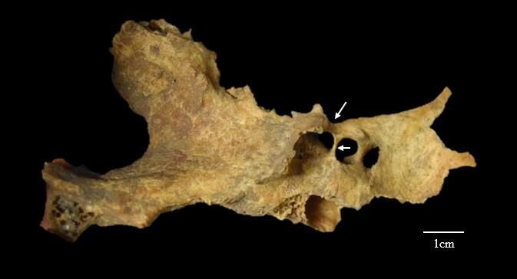
Figure S1. Complete bridging of the sella turcica as a consequence of the ossification of the interclinoid (long arrow) and the carotico-clinoid (short arrow) ligaments.
With regards to palaeopathology, on the frontal area, there are blastic lesions in the form of two irregular outgrowths as well as generalised expansion of the endocranial layer of compact bone suggestive of hyperostosis frontalis interna (HFI). HFI is characterised by the continuous growth of the frontal bone and has been described as a common finding in older females (Ortner 2011); it has recurrently been associated with hormonal stimulation (Hershkovitz et al. 1999; She & Szakacs 2004). Clinically, HFI has been associated with frontal headaches, psychoneurosis, obesity, pregnancy, acromegaly, virilism, hypertrichosis, and diabetes (She & Szakacs 2004); however, it is largely asymptomatic at the early stages of disease development (Wilczak & Mulhern 2012). The isolated lesions observed in Individual 1 from Loch Borralie were at the earliest stages of development, or Type A using Hershkovitz et al. (1999) classification and might have been asymptomatic. Additionally, Schmorl’s nodes are observable in L2, and L4 show and discarthrosis at the inferior endplate of L2 and at the superior endplates of L3 and L4. Osteoarthrosis is observable at multiple vertebral apophyseal joints (left inferior of C4; left superior of C5; right inferior of L5; and right superior of S1), as well as the tubercular articular facet of two ribs.
The most salient findings are the several instances of blunt force trauma and the evidence of postmortem intentional manipulation. Whilst most of the fragments show break surfaces that are consistent with post-mortem damage, an isolated cranial fragment consisting of the lateral parts and the basilar portion of the occipital bone along with a portion of the sphenoid (main text Figure 5a) shows a combination of post-mortem damage and some break surfaces that are smooth in texture and oblique in orientation, have sharp margins and have the same colouration as the rest of the bone (Craig et al. 2005; Knüsel 2005). Additionally, the right side of the occipital bone shows three radiating fractures (Figure S2). All these characteristics suggest that the bone was still wet at the time of breakage. In a modern context, cranial base fractures are associated with high-velocity impact usually as a result of motor vehicle collision, sport accidents and, less frequently, falls or assault (Bobinski et al. 2016; Figure S3). In palaeopathology, these types of fractures have been associated with hanging (Waldron 1996) -- falling from a height where the transmission of forces from the feet or buttocks through the spine to the cranium result in basilar ring fractures around the foramen magnum --and to impacts on the chin, which result in basilar fractures through the petrous portion and the mandibular condyles (Lovell 1997). In all cases, the fractures observable in the skull have relatively consistent patterns, but none of them is representative of the type of fracture observed in Individual 1 from Loch Borralie. This could suggest that the fracture was most likely from an intentional and accurate impact rather than as a result of direct or indirect cranial trauma. Additionally, this individual shows bilateral fractures at the base of the scapular spine (main text Figure 5b). The surfaces of the fractures are smooth, follow the grain of the bone and show areas of splintering, suggesting that this trauma took place around the time of death. In clinical research, scapular fractures are very rare (0.4 -- 1% of all fractures and are often associated with high-energy impact).

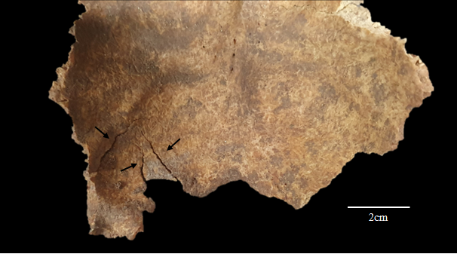
Figure S2. Endocranial view of the squama of the occipital bone showing three radiating fractures (arrows)

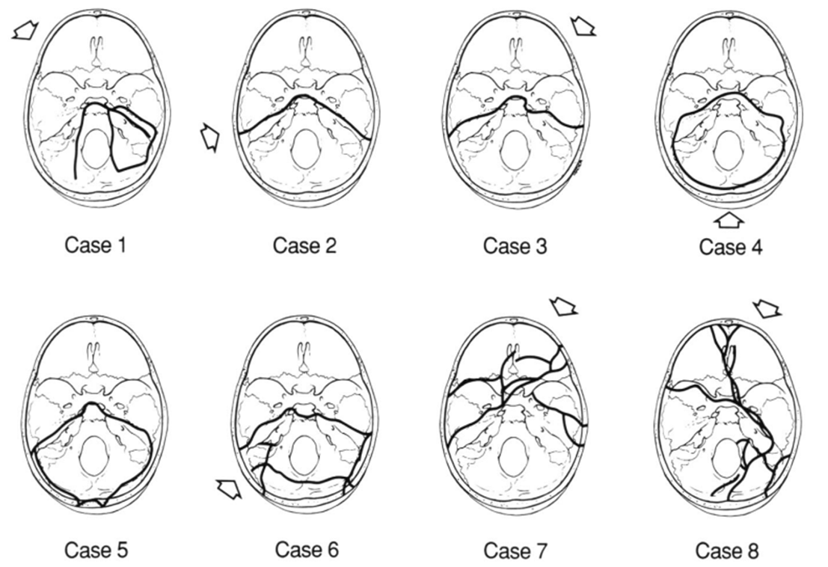
Figure S3. 1-7. Modern cases of temporal fractures resulting from motor vehicle accidents; 8. temporal fractures resulting from a fall from a height (from Pollanen et al. 1992).
There is possible evidence of intentional post-mortem manipulation of the cranium and the long bones. The endocranial surface of the frontal bone presents a series of parallel striations or incisions (Figure 5a) that could be interpreted as scratching/cutmarks, trampling marks, fungal activity or root etching. Trampling marks are caused by sedimentary friction against the cortical bone which create clusters of fine striations characterised by symmetrical and U-shaped cross-section, superficial nature and irregular groove trajectory (Madgwick 2014; Courtenay et al. 2020). There is usually a significant variability in the direction and size of trampling-related striations. It is worth noting that differentiating trampling and cutmarks can be very complicated (Madgwick 2014); however, the consistency in direction and spacing of the marks, mainly those which are transverse to the frontal crest, argues against the random and irregular trajectory characteristic of trampling marks. These incisions are also unlikely to be the result of fungal dissolution as the tracks or tunnels caused by this taphonomic agent have a diameter of 5 -- 10 µm and are visible only under electron microscopy (Jans et al. 2004). Finally, root marks are rarely straight for more than a few millimetres and, although they occur singly, they are often imbricated (Fernández–Jalvo & Andrews 2016); this is not observed on the endocranial surface of Individual 1. As such, the most probable cause of these marks is that they are cut or scratching marks. Because of the location of the lesion, it is impossible that this individual was alive when this occurred, and so they are classified as postmortem; however, it is not possible to know how long after death this event may have taken place. Nonetheless, considering the unusual peri-mortem fracture at the base of the cranium previously described, it is possible that it would have provided access to the inside of the cranium for the activity that caused the possible endo-cranial incisions.
Both humeri and the left ulna are only present at 50% and taper towards the end of the respective fragments, with the outer layers of the cortical bone removed and the internal layers worked to a sharp edge and a singular pointed end. On the right and left humerii, a clear space has appeared between the outer cortical layer and the tapering internal one. The left femur shows a similar tapering modification but instead of finishing in a sharp edge, it has a flat margin. Originally, these changes were associated with rodent gnawing (MacGregor 2003). However, the absence of the parallel marks that would be expected if rodent activity had caused these modifications (main text Figure 6b) argues against this hypothesis. Analysis using reflectance transformation image (RTI) to investigate the surface characteristics of the tapering, the formation of the point, and the sharpening of the edges revealed, on the right humerus, a U-shaped mark consistent of a whittling scar which would suggest that a sharp implement – such as a knife – may have been used to work the bone to its final shape (main text Figure 6c). The same method also revealed that the flat margin on the distal femur shows no visible striations (main text Figure 6d), suggesting that the bone may have been worked either against a soft surface, like a hide, or using a lubricant, such as water. In all cases, it is likely that the bones would have been first broken in half and then worked.
There is evidence of worked human bone or post-mortem treatment and curation of skeletal remains in European prehistoric contexts (e.g. Andrews & Fernández-Jalvo 2003; Santana et al. 2019; Laffranchi et al. 2023; Veselka et al. 2024). Likewise, in prehistoric Britain, long-term curation, retention and ‘mummification’ of skeletal remains has been identified in sites such as Middle Bronze Age (c. 1500 – 1200 BC) Canada Farm (Cranborne Chase, Dorset) and Bronze Age remains from Cladh Hallan, South Uist (Parker Pearson et al. 2005; Smith et al. 2016). Considering these precedents, the possibility that the remains from Individual 1 from Loch Borralie belonged to multiple individuals should be considered; however, there is no osteological basis to support this hypothesis: the long bones show very similar build and structure, and there is no obvious discrepancy in the age and sex estimation results from different skeletal and dental elements. Therefore, it is likely that the remains from Individual 1 belonged to a single female adult individual who received extensive post-mortem manipulation before being buried in correct anatomical position (main text Figure 3).
Individual 2
Skeletal inventory
Skull
 | Present (P) / Absent (A) |  | Comment
 | Right | Left
Frontal | P | P | Metopic suture (Figure S4)
Parietal | P: Anterior ½ only | P: Antero-inferior quadrant (in squamosal suture) only | Both very damaged
Occipital pars basilaris | P
Occipital pars lateralis | A | P
Pars squama (occipital) | A
Temporal (pars squama) | N | Y
Temporal (pars petrosa) | Y | Y
Zygomatic | Y | Y
Sphenoid (body) | Y
Sphenoid (lesser wings) | Y | Y
Sphenoid (greater wings) | Y | Y
Maxilla | Y | Y
Mandible | Y | Y | Bingle mental tubercle at  the mid-line
Malleus | N | N
Incus | N | N
Stapes | N | N

Axial Skeleton
 | Presence/absence | Comments
Atlas | P | White discolouration, posterior demiarch missing
Axis | P | White discolouration, spinous process and right lamina missing
Cervical vertebral bodies | 4 | Very poor preservation except 3-6
Cervical vertebral arches | 5
Thoracic vertebral bodies | 3 | Very damaged
Thoracic vertebral arches | 12 | Mostly well identifiable
Lumbar vertebral bodies | 0
Lumbar vertebral arches | 5 | 1, 3, 4 well preserved, 2 and 5 very fragmented
Sacral vertebral bodies | 0
Sacral vertebral arches | 0
Other vertebral elements | 0

Ribs
Right vertebral end | Right sternal ends | Left vertebral end | Left sternal ends
9 (inc. 1 and 2) | 4 | 2 | 4
Comment on ribs:
Despite the fragments identified, there are 10 more fragments of cortical bone belonging to ribs that could not be allocated a side or a region. In general, the right ribs are well preserved but the left ones are very damaged. A fragment of L rib also has a white discolouration.

Ossa Coxae
 | Right | Left | Comment
Pubis | A | A
Ischium | A | A
Ilium | P | A
Comments on the ossa coxae:
Of the right ilium, there is only a fragment of the postero-medial half, with the superior half of the auricular surface. The preservation is extremely poor and there is still sand within the trabecular bone. There is another fragment of os coxae with a portion of an acetabulum; by comparison, it does seem to also belong to the right side.

Upper appendicular skeleton
Bone | Right | Left | Comment
Clavicle | P: Epiphyses damaged | A
Scapula | P: Acromion, blade, supraspinal area and vertebral margin missing. Coracoid proc. unfused but present | A
Humerus | P: prox and distal metaphysis damaged, prox epiph visible | P: prox and distal ⅕ missing
Ulna | P: Extremely damaged prox ⅓ without olecranon, only anterior ½ remains. | A
Radius | P | P | 1 fragment with very damaged radial tuberosity and another diaphyseal, not the same side, too damaged to side.
Comments on upper appendicular bones:
In general, very poor cortical preservation, with peeling of the cortical surface and root etching.
There are only four diaphysis of metacarpals, most likely 1 – 3 and 4 or 5 but siding is not possible. There are 2 definite proximal phalanges (1st and another), and there are 6 other fragments of phalanges that could be proximal or intermediate.

Lower appendicular skeleton
Bone | Right | Left | Comment
Femur | A | A | Fragment of potentially femoral diaphysis
Patella | A | A
Tibia | P: Diaphyseal fragment, very damaged | A
Fibula | A | A
Comments on lower appendicular bones:
No foot bones present

Dental inventory
Abscess | 0 | 0 | 0 | 0 | 0 | - | 0 | 0 | 0 | 0 | 0 | 0 | 0 | 0 | 0 | 0 | Abscess
Caries | 0 | 0 | 0 | 0 | 0 | - | 0 | 0 | 0 | 0 | 0 | 0 | 0 | 0 | 0 | 0 | Caries
Calculus | 0 | 0 | 0 | 0 | 0 | - | 0 | 0 | 0 | 0 | 0 | 0 | 0 | 0 | 0 | 0 | Calculus
Wear | 1 | 2 | 2 | 2 | 2 | - | 2 | 3 | 3 | 2 | 3 | 2 | 2 | 2 | 2 | 1 | Wear
Tooth | P | P | P | P | P | / | P | P | P | P | P | P | P | P | P | P | Tooth
Al. bone | P | P | P | P | P | P | P | P | P | P | P | P | P | P | P | P | Al. bone
R max | M3 | M2 | M1 | P2 | P1 | C | I2 | I1 | I1 | I2 | C | P1 | P2 | M1 | M2 | M3 | L max

R mand | M3 | M2 | M1 | P2 | P1 | C | I2 | I1 | I1 | I2 | C | P1 | P2 | M1 | M2 | M3 | L mand
Al. bone | P | P | P | P | P | P | P | P | P | P | P | P | P | P | P | P | Al. bone
Tooth | P | P | P | P | P | P | P | P | P | P | P | P | P | P | P | P | Tooth
Wear | 1 | 2 | 3 | 2 | 2 | 2 | 2 | 3 | 3 | 2 | 2 | 2 | 2 | 3 | 2 | 1 | Wear
Calculus | 0 | 0 | 0 | 0 | 0 | 0 | 0 | 0 | 0 | 0 | 0 | 0 | 0 | 0 | 0 | 0 | Calculus
Caries | 0 | 0 | 0 | 0 | 0 | 0 | 0 | 0 | 0 | 0 | 0 | 0 | 0 | 0 | 0 | 0 | Caries
Abscess | 0 | 0 | 0 | 0 | 0 | 0 | 0 | 0 | 0 | 0 | 0 | 0 | 0 | 0 | 0 | 0 | Abscess
Dental nomenclature (numbering) follows the World Dental Federation (FDI) notation
‘Alveolar bone’ is recoded as: P if present, D if evidence of periodontal disease or X if absent
‘Tooth’ is recorded as: P if present, / if lost postmortem, X if lost ante-mortem or A for agenesis
‘Wear’ is recorded according to stages from Smith (1984)
‘Calculus’ is recorded according to grades from (Dobney & Brothwell 1987) on the buccal/labial surface of the tooth.
‘Caries’ is recorded as C if present or 0 if absent
‘Abscess’ is recorded as A if present or 0 if absent

Dental description
All teeth present, except for the URC, and in excellent state of preservation. All teeth show minimal dental wear and the four M3s are still inside the alveoli. Additionally, there is dental crowding on the right hemimandible, with the canine protruding anteriorly and the lateral incisor having erupted lingually to the line described by the other incisors (photo).
Osteoarchaeological analysis of Individual 2
Individual 2 from Loch Borralie is a juvenile of between 14.5 and 15.5 years of age at the time of death considering dental development and eruption; the very poor preservation of the metaphyseal plates makes it difficult to assess epiphyseal fusion. Sex has not been estimated for this individual because the dimorphic characters that allow the assessment would not have been fully developed. With regards to non-metric traits, despite being a juvenile, Individual 2 shows retention of the metopic suture. This developmental feature is, most often, fused by 8 months (van der Meulen 2012).
With regards to palaeopathology, this individual shows a plaque of periosteal new bone at the roof of the orbit. This lesion is proposed to be a diagnostic feature of vitamin C deficiency, or scurvy, according to the weighted method developed by Snoddy and colleagues (2018). However, due to the poor preservation or absence of other skeletal areas (e.g. greater alae of the sphenoid, supraspinous fossa of scapula), it is not possible to assess for additional porotic or periostotic lesions that would confirm the diagnosis of scurvy (Snoddy et al. 2018). It is, however, notable that this individual also shows linear enamel hypoplasia (LEH) on mandibular and maxillary canines and incisors. The disruptions in the development of the enamel, which LEH reflects, have been linked to physiological stress during development associated with nutritional deprivation, infectious disease and even trauma (Temple 2014) although it has been suggested that environmental and genetic factors may also influence the appearance of these defects (Towle & Irish 2020). It is therefore possible to say that Individual 2 may have suffered periods of growth disruption and malnutrition during development.
This individual also shows a small cortical defect on the right superior articular facet of the C2, and the fusion of C4 and C5 through the right transverse region and lamina (Figure S4), creating a block vertebra. The bodies of these two vertebrae are well separated and the left half of both vertebrae appear normal with extant superior and inferior apophyseal facets and distinct laminae. On the left side of C5, there is a pseudo-joint, due to a failure of fusion, between the left vertebral arch and the vertebral body. The segmentation corresponds to the area where the ossification centre of the vertebral body and that of the vertebral arch should have fused. The vertebral arch of C5 that is not fused to C4 consists of the transverse region (with the apophyseal facets), the left lamina and spinous process. On the right side, the lamina of C5 overlaps with that of C4, forming a combined lamina with an articular surface for C6. Together, the right laminae of C4 and C5 also create the apophyseal surface to which C6 articulates.
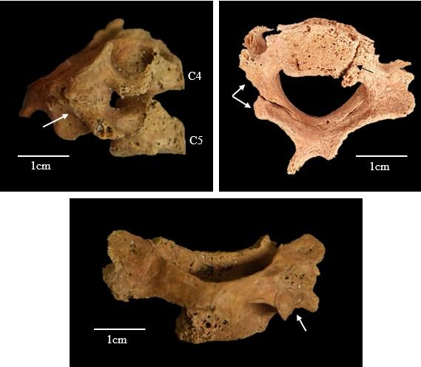
Figure S4. Fusion of C4 and C5. Top left: Lateral view, note the clear separation of the vertebral bodies, and the absence of the inferior apophyseal surface of C4 and the superior surface of C5 (arrow). Top right: Inferior view of the C4--C5 vertebral block. Note the pseudo-joint on the left side of C5 formed between the body and the pedicle (black arrow). There is also a long additional articulation surface at the inferior aspect of the right lamina of C4--C5 that would articulate with C6 (twin white arrows). Below: posterior view, note the shared lamina and spinous process. The apophyseal joint between C5 and C6 is also visible (arrow).

The fusion of two vertebrae can be caused by infectious diseases, trauma or congenital vertebral malformation (Rusconi & Maestretti 2018; Redfern & Roberts 2019: 444; Roberts & Buikstra 2019: 590). In the fusion of two vertebrae as the result of a traumatic incident, it would be expected that the callus formed in the fusion would be still clearly visible and it usually has an irregular surface. However, when the block is the result of a congenital vertebral malformation, the vertebral body, shape and structure of the lamina or the articulating surfaces may be affected but do not show bone remodelling. In this case, the most likely aetiology of this vertebral malformation is a congenital failure of segmentation. Vertebral malformations can be found in isolation or, occasionally, can be part of a syndrome (Chaturvedi et al. 2018). Congenital syndromes that are characterised by cervical structural abnormalities include Klippel-Fiel Syndrome, Down Syndrome or diastrophic dysplasia, among others (McKay et al. 2012; Hukeľová & Krošláková 2021). Other than the vertebral malformations described, no other skeletal abnormalities have been identified in Individual 2 from Loch Borralie, which may suggest that this is an isolated developmental malformation; however, the preservation of this individual was poor and so it is possible that additional lesions that would have helped in the diagnosis have been lost.
Finally, it is worth noting the changes in cortical colour observed in the cranium, mandible and cervical vertebrae of this individual (Figure S5). The petrous portion of the right temporal bone, as well as the fragment of right parietal bone, are of a white colour; the remaining bones are of a light brown colour.
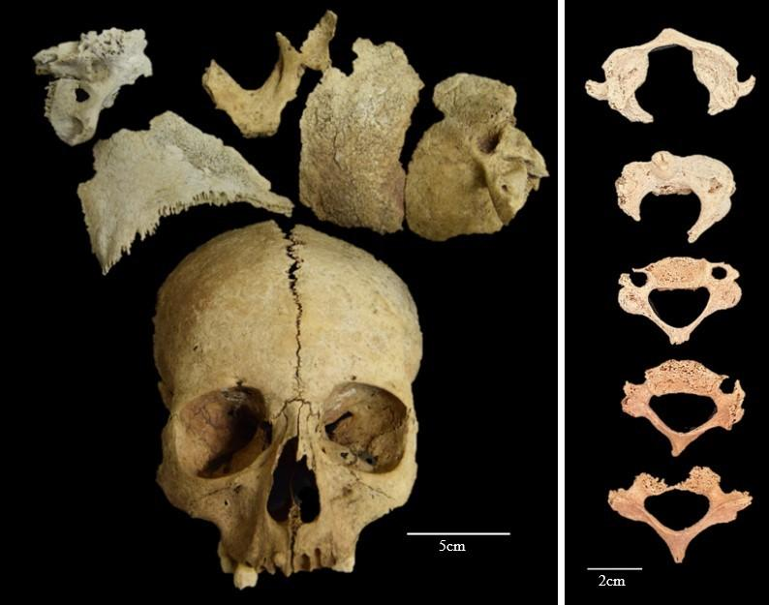
Figure S5. Cranium and cervical vertebrae of Individual 2. Note the open metopic suture on the frontal bone and the substantial difference in bone colour between the right side (white) and the left side (stained)
Additional fragments:
Additionally, there are three fragments and an adult os coxae associated with this individual (were found inside the bag of long bones):
- Fragment of adult long bone (femur?): it is the same white colour as the cranial bones and it is very taphonomically damaged, with possible perforations within the cortical bone.
- Left adult os coxae (ilium and ischium) with complete fusion: this element possibly belongs to Individual 1.
2cm
- Vertebra of a small animal

Ancient DNA analysis: technical report
Introduction

Ear ossicles from Individuals 1 and 2 at Loch Borralie were successfully analysed for aDNA. Analysis was undertaken at the Harvard Medical School ancient DNA facilities. Powdered samples were obtained in a clean dedicated room. DNA was extracted using a method that is optimised to retain small DNA fragments (Dabney et al. 2013; Rohland et al. 2018). Between one and four double-stranded libraries were built for each sample with the enzyme Uracil-DNA Glycosylase (UDG) to remove characteristic ancient DNA damage and thereby greatly reduce the rate of damage-induced errors (Rohland et al. 2015). Libraries were enriched both for sequences overlapping mitochondrial DNA (Fu et al. 2013) and for sequences overlapping about 1.2 million nuclear targets (Fu et al. 2015; Mathieson et al. 2015) and then sequenced. The reads obtained after sequencing were aligned to the human genome reference with quality filters to assess the integrity of the sequences under study.

Sequencing results are summarised in the main text (Table 2). Molecular sex of both individuals was determined using the method of Skoglund et al. (2013): Individual 1 (I37347) was determined to be female and Individual 2 (I37348) male. Both shared the mtDNA-haplogroup T2b30; a subclade of group T2b, which is common in Europe (Hay 2016). We found only one other example of this subclade in the AADR database, however, corresponding to an individual from Poland dated from 4335–4058 calBCE (5380±35 BP, Poz-77330) (Mallick et al. 2024).
Kinship analysis
We performed kinship analysis using the software READv2 (Relationship Estimation from Ancient DNA; Monroy Kuhn et al. 2018; Alaçamlı et al. 2024). Despite the uncommon shared mtDNA-haplogroup, we were unable to detect any biological relationship between the two individuals up to the third degree.
IBD analysis
Identity-by-Descent (IBD) analysis was performed to investigate more distant potential biological relationships between Individuals 1 and 2 and previously published individuals from the AADR v62 dataset (Mallick et al. 2024), using the ancIBD tool (Ringbauer et al. 2023). The results are summarised in Table S1. Individuals 1 and 2 share a total of 43.34 cM across four segments longer than 8 cM and one segment exceeding 12 cM, consistent with a potential distant genetic relationship, likely of fifth degree or more. Additionally, Individual 1 (I37347) shows evidence of distant genetic relationship with I2982 (Bu, Orkney), sharing a segment of 13.70 cM, potentially of eighth 8th or higher degree. while Individual 2 (I37348) shows evidence of a distant genetic relationship with KD043 (Knowe of Skea, Orkney), also suggestive of relationships of at least the eighth degree.
Phenotypes
Using the HIrisPlex SNPs panel (Walsh et al. 2013; Chaitanya et al. 2018), which analyses 41 SNPs, to predict eye and hair colour, and skin pigmentation, we were able to predict eye and hair colour for both individuals:
- Individual 1 (I37347) has a substantial probability of having blue eyes (p = 0.90), blond (p = 0.71) and light (p = 0.96) hair.
- Individual 2 (I37348) has a substantial probability of having brown eyes (p = 0.95), brown (p = 0.78) and dark (p = 0.96) hair.
Population genomics analysis
In order to carry out population genomics analysis, we used the database provided by the David Reich Laboratory (which curates previously published data from many sources), and which is available at: https://dataverse.harvard.edu/dataset.xhtml?persistentId=doi:10.7910/DVN/FFIDCW
To analyse the relationship between the archaeological samples and the modern population, we performed a principal component analysis (PCA), where the genotypes of modern individuals from across Western Europe were analysed, and the ancient individuals were projected using smartPCA (Patterson et al. 2012; Figure S6).
The PCA analysis shows that the two individuals plot closely together, grouping closely with modern Scottish and Norwegian populations, and with Iron Age Scottish (and to a lesser degree English and Welsh) individuals (Figure S6).
We performed a qpAdm analysis to estimate the admixture weights of the contribution of various ancestry components to each individual (Figure S7), using the database published by Patterson et al. (2022). We can observe that the contribution of Early European Farmer ancestry (EEF) was 36.4% for Individual 1 (I37347) and 33.6% for Individual 2 (I37348). These results are commonly observed in Iron Age individuals from England (37.9 ± 0.4%) and Scotland (33.4 ± 0.6%) (Patterson et al. 2022).
We carried out an f3 analysis in the form f3(Mbuti; Ancient population, Individual*) where we tested the affinity of both individuals from Loch Borralie with Iron Age groups defined by Patterson et al. (2022) as England.and.Wales, Scotland, France.Switzerland, CzechRepublic.Slovakia.Germany, and Netherlands, and with EEF and Steppe populations (Figure S8a). A high f3 result indicates high affinity between the individuals and the compared populations. We also analysed the percentage of Steppe and EEF contribution to each individual using the qpAdm method (Figure S8b).
We can observe that the Loch Borralie individuals have a similar affinity and contribution of EEF and Steppe ancestry to other individuals from Iron Age Scotland and England (Figure S8).
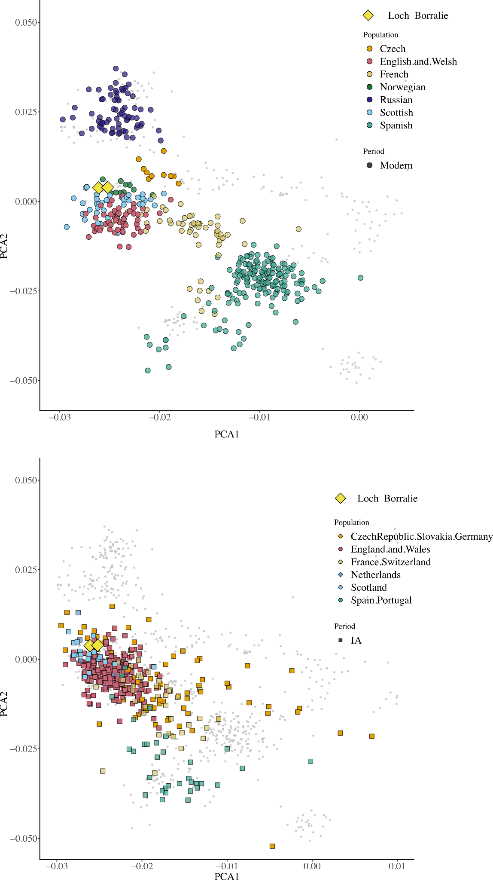
Figure S6. Top) Principal Component Analysis (PCA) of Western Europe's modern population with ancient individuals from Loch Borralie (yellow diamonds) projected using smartPCA (Patterson et al. 2012). Bottom) PCA of ancient individuals from the Iron Age (IA) closely related to the Loch Borralie individuals. Small grey dots represent modern individuals
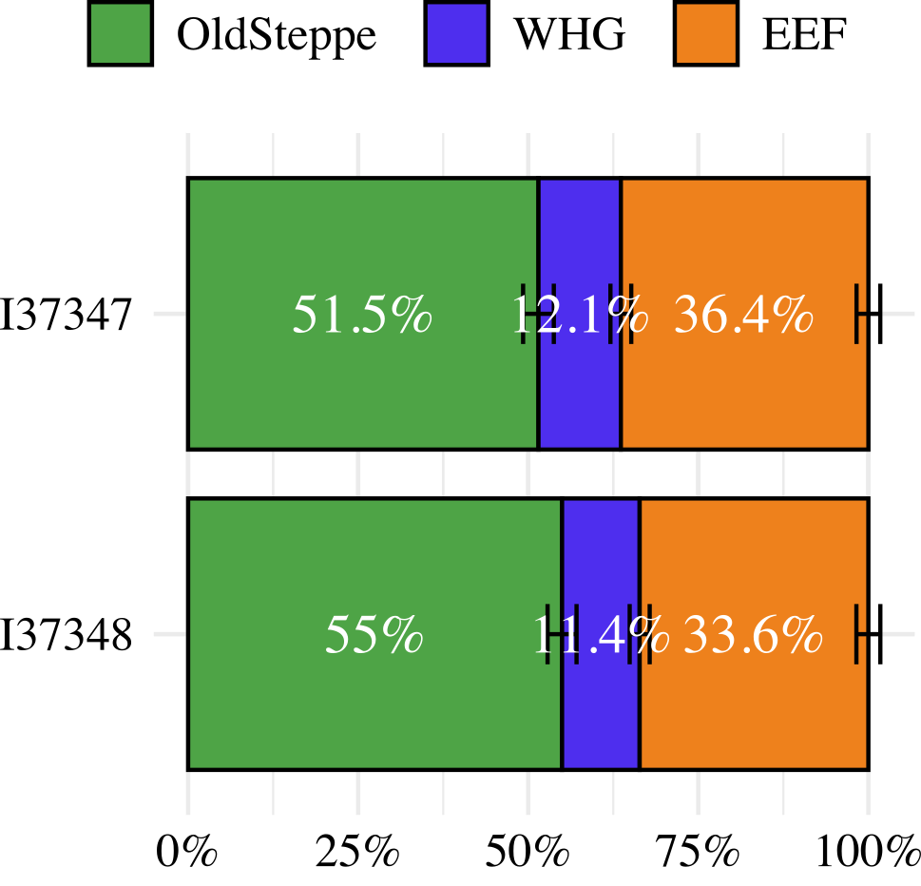
Figure S7. Percentage contribution of ancient populations to each individual from Loch Borralie.

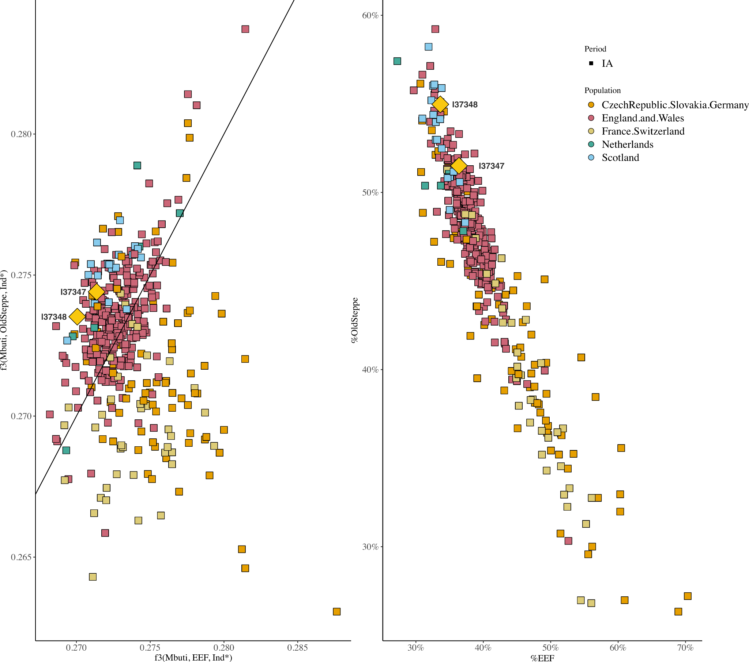
Figure S8. Left) Affinity between each Loch Borralie individual, with EEF and Steppe populations. Right) Percentage of contribution of Steppe and EEF ancestry to each Loch Borralie individual.
We used a qpWave analysis to evaluate whether the two Loch Borralie individuals presented statistically significant differences in their genetic makeup. A P-value from the qpWave test greater than 0.01 indicates that individuals can be grouped into a homogeneous group (Fernandes et al. 2020). For this, we used the outgroup formed by "Mota", "Ust_Ishim", "MA1", "Villabruna", "Mbuti", "Papuan", "Onge", "Han", "Karitiana", "Turkey_N" and "OldSteppe".
The results show that the two Loch Borralie individuals form a homogeneous group (qpWave P-value = 0.76). We then used f3 and qpWave analyses to determine the contemporary groups most closely related to the Loch Borralie ‘group’. The f3 analysis helps identify shared genetic drift between populations, indicating common ancestry or admixture events. The qpWave analysis, on the other hand, assesses whether the Loch Borralie individuals can be considered part of the comparison group, and thus whether they form a genetically homogeneous group (Fernandes et al. 2020; Patterson et al. 2022).
Table S1: IBD analysis showing shared segments between individuals from Loch Borralie and published individuals from the AADR database V62 (Mallick et al. 2024); KD043 from Knowe of Skea (Orkney, Scotland) dated 25-215 cal AD (1915±35 BP; SUERC-8410), and I2982 from Bu (Orkney, Scotland) dated 395-207 cal BC (2260±29 BP; SUERC-68733).
Sample 1 | Sample 2 | max_IBD (cM) | sum_IBD>8 cM | n_IBD>8 cM | sum_IBD>12 cM | n_IBD>12 cM | Degree
Loch Borralie Ind. 1  (I37347) | Loch Borralie Ind. 2  (I37348) | 12.14 | 43.34 | 4 | 12.14 | 1 | 5th+
Knowe of Skea  (KD043) | Loch Borralie Ind. 2  (I37348) | 13.68 | 22.75 | 2 | 13.68 | 1 | 6th+
Loch Borralie Ind. 1  (I37347) | Bu  (I2982) | 13.70 | 13.70 | 1 | 13.70 | 1 | 8th+
The Loch Borralie individuals presented the highest affinity with the Scotland Iron Age (IA) group (f3 - Estimation ~2.28) (Table S2). The qpWave analysis shows that these individuals can be grouped with Scotland IA (qpWave P-value 0.04), a group of individuals from England and Wales IA/Roman period (qpWave P-value = 0.016) and the Netherlands IA group (qpWave P-value 0.39).

Table S2: Affinity and qpWave analysis results for Loch Borralie. The target groups are ordered by affinity estimation
 | Affinity estimation between Loch Borralie and a target group  f3(Mbuti, Target, Loch Borralie) |  |  |  | qpWave analysis
Target groups | Affinity Estimation | S.E | Z-Score | Number of SNPs | Chisq | P-value
Scotland_IA | 0.280 | 0.002 | 128.345 | 890093 | 18.987 | 0.040
England.and.Wales_IA_Roman | 0.278 | 0.002 | 123.454 | 899256 | 21.765 | 0.016
England.and.Wales_IA | 0.278 | 0.002 | 129.180 | 1005231 | 31.829 | 0.000
Channel.Islands_IA | 0.278 | 0.002 | 114.808 | 478854 | 47.394 | 0.000
Netherlands_IA | 0.276 | 0.002 | 115.603 | 627889 | 10.535 | 0.395
France.Switzerland_IA | 0.276 | 0.002 | 126.124 | 932939 | 103.422 | 0.000
CzechRepublic.Slovakia.Germany_IA | 0.276 | 0.002 | 127.979 | 973447 | 107.683 | 0.000
Austria.Hungary.Slovenia_IA | 0.275 | 0.002 | 127.535 | 980883 | 165.134 | 0.000
Croatia.Serbia_IA | 0.275 | 0.002 | 124.355 | 863616 | 238.702 | 0.000
Spain.Portugal_IA | 0.274 | 0.002 | 127.111 | 931020 | 293.022 | 0.000

Data Availability
The raw data are available as aligned sequences (bam files) through the European Nucleotide Archive under accession number PRJEB106907 .

Multi-isotope analysis: technical report
Background
Strontium (⁸⁷Sr/⁸⁶Sr) and oxygen (δ¹⁸O_{carb}) isotope analysis of tooth enamel can be used to investigate residential origins during the time of tooth formation (Evans et al. 2006). While many factors must be considered when trying to identify archaeological migrants (Montgomery 2010), the ⁸⁷Sr/⁸⁶Sr of human enamel generally relates to the region where the food consumed was produced/acquired and primarily reflects the strontium composition of the local geology. Carbonate oxygen isotopes (δ¹⁸O_{carb}) reflect the isotope values of ingested water, which is linked to local precipitation and, therefore, can be used as a geospatial indicator (Sharp 2017). For a review of the applications and potential of oxygen isotopes in bioarchaeology, including identifying human migrants, see Lightfoot and O’Connell (2016) and Pederzani and Britton (2019).

Stable isotope analysis of dentine collagen and bone provides insights into average protein dietary intake (Ambrose & Norr 1993). Carbon (δ¹³C) isotopes can distinguish between plant groups (C₃ vs C₄) due to the differences in carbon pathways and can be used to differentiate between marine and terrestrial food chains (Lee-Thorp et al. 1989; Richards & Hedges 1999; Richards et al. 2003). δ¹³C_{Carb} of dental enamel reflects whole dietary intake, including carbohydrates and lipids (Loftus & Sealy 2012) and is therefore a useful additional proxy for determining diet. Nitrogen (δ¹⁵N) stable isotope analysis can determine trophic level, and distinguish between terrestrial and aquatic sources (Hedges & Reynard 2007). Sulfur (δ³⁴S) isotope analysis can help expand dietary reconstructions based on δ¹³C and δ¹⁵N, including aquatic versus terrestrial diets, where the sulfur composition of these two ecosystems differs sufficiently (Nehlich 2015). It can also be used for provenance to explore whether individuals lived (or acquired food) in coastal environments or wetlands (Craig et al. 2006; Lamb et al. 2023). In this study, the carbon isotopic composition of both tooth dentine and tooth enamel was determined.
BGS Biosphere Isotope Domains Database and predicted biosphere values for Loch Borralie
Loch Borralie is situated close to the north-west extremity of the Scottish mainland on a peninsula between Balnakeil Bay and the Kyle of Durness. The dominant bedrock is carbonate of the Durness Group (dolostones with intervals of dolomitic limestone, limestone, and subordinate chert), which is of Cambrian to Ordovician age (British Geological Survey 2020; British Geological Survey 2025). The cairn is located against an outcrop of quartzite (MacGregor 2003).
The BGS Biosphere Isotope Domains map website (Evans et al. 2022) has been used to restrict the possible childhood residential origins of the two Loch Borralie individuals based on their strontium and oxygen isotope composition. Interrogation of the Sr domain map is based on matching the unknowns to the data range of the domains, which is based predominantly on modern plant data (n = 1385). Two levels of interrogation are available: firstly the central 50% or interquartile range, which is recommended for human data and secondly, the central 90% used for herbivores. As recommended, this study used the central 50% match method. The oxygen BGS dataset is derived from human enamel samples from individuals deemed to be of a local origin. The data have been allocated into two geographical zones using the -7‰ to -8‰ drinking water contour as a boundary. The predicted strontium isotope biosphere value for this area (central 50% medium) is between 0.7094 and 0.7096 and the estimated oxygen δ¹⁸O_{carb} ‰ (VSMOW) for human enamel is 26.5‰ -- 27.5‰ (BGS Biosphere Map; Evans et al. 2022).
Tooth enamel preservation assessment and preparation of samples
Overall enamel preservation was assessed and assigned a score (0--6) according to the preservation classification system developed by Janet Montgomery (2002) for her PhD research. Both teeth were assigned an enamel preservation score of 3 - good: “...fine cracks, post-mortem surface concretions or superficial plant root abrasion may be present. On cleaning, enamel is hard, translucent and glossy with no obvious discoloration. EDJ is intact but may be discoloured.” (Montgomery 2002, Chapter 5, tab. 5.1). Both teeth had fully formed roots.
Strontium-oxygen-carbon isotope analysis of tooth enamel was performed at the British Geological Survey laboratory (Keyworth, UK). The enamel tooth surface was cleaned by abrasion, using a diamond burr, to a depth of about 100 microns, to remove surface contamination on the outer side of the enamel. A sample of c. 50mg was then cut from the tooth and any residual dentine was completely removed from the inner enamel surface. This enamel was roughly crushed using an impact mortar and split into two subsamples: c. 5 mg for oxygen isotope analysis and the remaining material for strontium and lead isotope analysis. The lead isotope results will be reported in a separate study. The samples for oxygen analysis were further reduced to a powder in an agate mortar and pestle.
Strontium (⁸⁷Sr/⁸⁶Sr) isotope analysis of tooth enamel
The enamel sample was transferred to a clean (class 100, laminar flow) working area for further preparation. The sample was first cleaned ultrasonically in high purity water to remove dust, rinsed twice, and then soaked for an hour at 60°C, rinsed twice, then dried and weighed into pre-cleaned Teflon© beakers. ⁸⁴Sr tracer solution was added and the samples were dissolved in Teflon© distilled 8M HNO_{3.} After evaporation to dryness, the sample was converted to bromide form by the addition of 0.5M Ultrapur© HBr. Strontium was collected using Eichrom AG50 X8 resin columns (Dickin 1995).
Strontium was loaded onto a single Re Filament following the method of Birck (1986) and the isotope composition and strontium concentrations were determined by Thermal Ionisation Mass spectroscopy (TIMS) using a Thermo Triton multi-collector mass spectrometer. The international standard for ⁸⁷Sr/⁸⁶Sr, NBS987, gave a value of 0.710262±0.000018 (2SD; n = 10) during the analysis of these samples. Data are corrected to an accepted value for this standard of 0.710250.
Carbonate oxygen (δ¹⁸O_{carb}) and carbon (δ¹³C_{carb}) isotope analysis of tooth enamel
Approximately 400μg of powdered, homogenised tooth enamel carbonate was loaded into septa-sealed 1.0 mL WHEATON NextGen V Vial vials. The vials were placed in an Elementar iso CARB PREP kept at 90°C that is connected on-line to an iso DUAL INLET and isoprime precisION isotope ratio mass spectrometer (IRMS). The automated system evacuates the vials and delivers vacuum-distilled anhydrous phosphoric acid to the samples. The evolved CO₂ is passed through a water trap and collected under liquid nitrogen for 9 minutes, cryogenically cleaned, and passed to the IRMS for carbon (δ¹³C) and oxygen (δ¹⁸O) isotope analysis. The sample gas ¹³C/¹²C and ¹⁸O/¹⁶O ratios were measured six times against a working CO₂ reference gas of unknown isotope composition and averaged. Isotope values are reported in standard delta (δ) notation in per mil (‰) calculated to the Vienna Pee Dee Belemnite (VPDB) scale based on a one-point calibration using a within-run laboratory Carrara marble standard (KCM; δ¹³C VPDB = +2.00‰, δ¹⁸O VPDB = −1.73‰). Scaling effects on the IRMS are negligible and checked regularly using IAEA-603, USGS44, and NBS18. The Craig correction was used to account for δ¹⁷O (Craig 1957; Gonfiantini 1981) and the carbonate-acid fractionation factor applied to the gas values is 1.00813 (Kim et al. 2007). Oxygen isotope values were converted to the VSMOW-SLAP scale using δ¹⁸O VSMOW-SLAP = 1.03092 × δ¹⁸O VPDB + 30.92‰ (Kim et al. 2015; Brand et al. 2014). The average analytical reproducibility of the laboratory KCM standard is typically < 0.1‰ for δ¹³C VPDB and δ¹⁸O VPDB.
Analytical reproducibility for this run of laboratory standard calcite (KCM) is ± 0.02‰ (1σ, n = 18) for δ¹³C_{PDB} and ± 0.05‰ (1 σ, n = 18) for δ¹⁸O_{SMOW (c).} External reproducibility of the enamel data based on the analysis of duplicate sample pairs was 0.02 or lower for δ¹⁸O_{SMOW(c)} and 0.09 or lower for δ¹³C_{PDB} (1σ, n = 2).
Stable carbon (δ¹³C), nitrogen (δ¹⁵N), and sulfur (δ³⁴S) isotope analysis of tooth dentine
Stable carbon (δ¹³C), nitrogen (δ¹⁵N), and sulfur (δ³⁴S) isotopic compositions were determined on a Delta V Advantage continuous-flow isotope ratio mass spectrometer coupled via a ConfloIV to an IsoLink elemental analyser (Thermo Scientific, Bremen) at SUERC, East Kilbride as described in Sayle et al. (2019).
Samples were combusted in the presence of oxygen in a single reactor containing tungstic oxide and copper wires at 1020°C to produce N₂, CO₂ and SO₂. A magnesium perchlorate trap was used to eliminate water produced during the combustion process, and the gases were separated in a GC column heated between 70°C and 240°C. Helium was used as a carrier gas throughout the procedure. N₂, CO₂, and SO₂ entered the mass spectrometer via an open split arrangement within the ConfloIV and were analysed against their corresponding reference gases.
The International Atomic Energy Agency (IAEA) reference materials USGS40 (L-glutamic acid, δ¹³C_{VPDB} = –26.39±0.04‰, δ¹⁵N_{AIR} = –4.52±0.06‰) and USGS41a (L-glutamic acid, δ¹³C_{VPDB} = 36.55±0.08‰, δ¹⁵N_{AIR} = 47.55±0.15‰) were used to normalise δ¹³C and δ¹⁵N values. Two in-house standards (5-SAAG, δ³⁴S_{VCTD} = –14.35±0.34‰ and GS4, δ³⁴S_{VCTD} = 18.50±0.25‰) that are calibrated to the International Atomic Energy Agency (IAEA) reference materials IAEA-S-2 (silver sulfide, δ³⁴S_{VCTD} = 22.62±0.08‰) and IAEA-S-3 (silver sulfide, δ³⁴S_{VCTD} = –32.49±0.08‰) were used to normalise δ³⁴S values. Results are reported as per mil (‰) relative to the internationally accepted standards VPDB, AIR and VCDT.
Normalisation was checked using the Elemental Microanalysis standards B2215 (fish gelatin: δ¹³C_{VPDB} = –22.92±0.10‰, δ¹⁵N_{AIR} = 4.26±0.12‰, and δ³⁴S_{VCTD} = 1.21±0.24‰), USGS88 (marine collagen: δ¹³C_{VPDB} = –16.06±0.07‰, δ¹⁵N_{AIR} = 14.96±0.14‰, and δ³⁴S_{VCTD} = 17.10±0.44‰) and USGS89 (porcine collagen: δ¹³C_{VPDB} = –18.13±0.11‰, δ¹⁵N_{AIR} = 6.25±0.12‰, and δ³⁴S_{VCTD} = 3.86±0.56‰), which gave the values:
B2215/Run date | δ¹³C_{VPDB} ‰ | δ¹⁵N_{AIR} ‰ | δ³⁴S_{VCTD} ‰
03/07/2023 | -23.01±0.15 (n = 4) | 4.51±0.17 (n = 4) | 1.24±0.20 (n = 2)
19/07/2023 | -22.97±0.06 (n = 4) | 4.24±0.09 (n = 4) | 1.08±0.24 (n = 4)

USGS88/Run date | δ¹³C_{VPDB} ‰ | δ¹⁵N_{AIR} ‰ | δ³⁴S_{VCTD} ‰
03/07/2023 | -16.21±0.06 (n = 4) | 15.22±0.20 (n = 4) | 18.15±0.13 (n = 3)
19/07/2023 | -16.28±0.08 (n = 4) | 15.20±0.06 (n = 4) | 18.16±0.59 (n = 4)

USGS89/Run date | δ¹³C_{VPDB} ‰ | δ¹⁵N_{AIR} ‰ | δ³⁴S_{VCTD} ‰
03/07/2023 | -18.15±0.07 (n = 4) | 6.31±0.19 (n = 4) | 4.24±0.42 (n = 4)
19/07/2023 | -18.17±0.10 (n = 4) | 6.24±0.04 (n = 4) | 4.10±0.34 (n = 4)

Precision is determined to be ±0.1‰ for δ¹³C, ±0.2‰ for δ¹⁵N and ±0.4‰ for δ³⁴S and is based on repeated measurements of the well-characterised Elemental Microanalysis IRMS fish gelatin standard B2215.
Data availability
Results are provided in the main manuscript; the full (δ¹³C_{carb}) and oxygen (δ¹⁸O_{carb}) carbonate results are shown in Table S3. Data will also be available in the IsoArcH database (https://www.isoarch.org).

Table S3: Carbon (δ¹³C_{carb}) and oxygen (δ¹⁸O_{carb}) isotope data for Loch Borralie
Sample | Average δ¹³C‰ | Average δ¹⁸O‰ | Average δ¹⁸O ‰ VSMOW | 1STDEV δ¹³C‰ | 1STDEV δ¹⁸O‰ | 1STDEV δ¹⁸O‰ VSMOW
Individual 1 | -14.58 | -5.04 | 25.73 | 0.001 | 0.09 | 0.09
Individual 2 | -15.86 | -4.60 | 26.18 | 0.02 | 0.07 | 0.08

References in Supplementary Material
Alaçamli, E., et al. 2024. READv2: advanced and user-friendly detection of biological relatedness in archaeogenomics. Genome Biology 25. https://doi.org/10.1186/s13059-024-03350-3
AlQahtani, S.J. et al. 2010. Brief communication: the London atlas of human tooth development and eruption. American Journal of Physical Anthropology 142: 481–90. https://doi.org/10.1002/ajpa.21258
Andrews, P. & Y. Fernández-Jalvo. 2003. Cannibalism in Britain: taphonomy of the Creswellian (Pleistocene) faunal and human remains from Gough’s Cave (Somerset, England). Bulletin of The Natural History Museum: Geology Series 58: 59–81. https://doi.org/10.1017/S096804620300010X
Ambrose, S.H. & L. Norr. 1993. Experimental evidence for the relationship of the carbon isotope ratios of whole diet and dietary protein to those of bone collagen and carbonate, in J.B. Lambert & G. Grupe (ed.) Prehistoric human bone: archaeology at the molecular level: 1–37. Berlin: Springer. https://doi.org/10.1007/978-3-662-02894-0_1
Aufderheide, A.C. et al. 2011. The Cambridge encyclopedia of human paleopathology. Cambridge: Cambridge University Press.
Bass, W.M. 2005. Human osteology: a laboratory and field manual. Columbia: Missouri Archaeological Society.
Berry, A.C. & R.J. Berry. 1967. Epigenetic variation in the human cranium. Journal of Anatomy 101: 361–79.
Birck, J.L. 1986. Precision K Rb Sr isotopic analysis: application to Rb Sr chronology. Chemical Geology 56: 73–83. https://doi.org/10.1016/0009-2541(86)90111-7
Bobinski, M. et al. 2016. Basic imaging of skull base trauma. Journal of Neurological Surgery Part B: Skull Base 77: 381–87. https://doi.org/10.1055/s-0036-1583540
Brahmbhatt, R.J. et al. 2015. Prevalence and dimensions of complete sella turcica bridges and its clinical significance. The Indian Journal of Surgery 77: 299–301. https://doi.org/10.1007/s12262-012-0800-5
Brand, W.A. et al. 2014. Assessment of international reference materials for isotope-ratio analysis (IUPAC Technical Report). Pure and Applied Chemistry 86: 425–67. https://doi.org/10.1515/pac-2013-1023
British Geological Survey. 2020. The BGS lexicon of named rock units [online]. Available at: https://webapps.bgs.ac.uk/lexicon/
− 2025. BGS geology viewer - the geological map viewer of Britain. Available at: https://geologyviewer.bgs.ac.uk/ (accessed 2 April 2025).
Brooks, S. & J. Suchey. 1990. Skeletal age determination based on the os pubis: a comparison of the Acsádi-Nemeskéri and Suchey-Brooks methods. Human Evolution 5: 227–38. https://doi.org/10.1007/BF02437238
Brothwell, D.R. 1981. Digging up bones: the excavation, treatment and study of human skeletal remains. Oxford, Oxford University Press/British Museum (National History).
Buckberry, J.L. & A.T. Chamberlain. 2002. Age estimation from the auricular surface of the ilium: a revised method. American Journal of Physical Anthropology 119: 231–39. https://doi.org/10.1002/ajpa.10130
Buikstra, J. & D. Ubelaker. 1994. Standards for data collection from human skeletal remains. Fayetteville, Arkansas Archaeological Survey.
Chaitanya, L. et al. 2018. The HIrisPlex-S system for eye, hair and skin colour prediction from DNA: introduction and forensic developmental validation. Forensic Science International: Genetics 35: 123–35. https://doi.org/10.1016/j.fsigen.2018.04.004
Chaturvedi, A. et al. 2018. Malformed vertebrae: a clinical and imaging review. Insights Imaging 9: 343–55. https://doi.org/10.1007/s13244-018-0598-1
Courtenay, L.A. et al. 2020. Scratches and grazes: a detailed microscopic analysis of trampling phenomena. Journal of Microscopy 277: 107–17. https://doi.org/10.1111/jmi.12873
Craig, H. 1957. Isotopic standards for carbon and oxygen and correction factors for mass-spectrometric analysis of carbon dioxide. Geochimica et Cosmochimica Acta 12: 133–49. https://doi.org/10.1016/0016-7037(57)90024-8
Craig, R.C. et al. 2005. Fragmentation, mutilation and dismemberment: an interpretation of human remains on Iron Age sites, in N. Thorpe & M. Parker-Pearson (ed.) Warfare, violence and slavery in prehistory (British Archaeological Reports International Series 1374): 165–80. Oxford: Archaeopress.
Craig, O.E. et al. 2006. Focus: sulphur isotope variation in archaeological marine fauna from northern Europe. Journal of Archaeological Science 33: 1642–46. https://doi.org/10.1016/j.jas.2006.05.006
Dabney, J. et al. 2013. Complete mitochondrial genome sequence of a Middle Pleistocene cave bear reconstructed from ultrashort DNA fragments. Proceedings of the National Academy of Sciences USA 10:15758–63. https://doi.org/10.1073/pnas.1314445110
Dickin, A.P. 1995. Radiogenic isotope geology. Cambridge: Cambridge University Press.
Dobney, K. & D. Brothwell. 1987. A method for evaluating the amount of dental calculus on teeth from archaeological sites. Journal of Archaeological Science 14: 343–51. https://doi.org/10.1016/0305-4403(87)90024-0
Erturk, M. et al. 2004. Anatomy of the clinoidal region with special emphasis on the caroticoclinoid foramen and interclinoid osseous bridge in a recent Turkish population. Neurosurgical Review 27: 22–26. https://doi.org/10.1007/s10143-003-0265-x
Evans, J.A. et al. 2006. Bronze Age childhood migration of individuals near Stonehenge, revealed by strontium and oxygen isotope tooth enamel analysis. Archaeometry 48: 309–21. https://doi.org/10.1111/j.1475-4754.2006.00258.x
– 2022. Biosphere isotope domains GB (V2): interactive website. British Geological Survey [dataset]. https://doi.org/10.5285/2ce7fc22-1b6e-4979-968f-42058c0120fb
Ferembach, D. et al. 1980. Recommendation for age and sex diagnoses of skeletons. Journal of Human Evolution 9: 517–49. https://doi.org/10.1016/j.jchb.2005.07.002
Fernandes, D.M. et al. 2020. The spread of steppe and Iranian-related ancestry in the islands of the western Mediterranean. Nature Ecology and Evolution 4: 334–45. https://doi.org/10.1038/s41559-020-1102-0
Fernández-Jalvo, Y. & P. Andrews. 2016. Atlas of taphonomic modifications. Dordrecht: Springer. https://doi.org/10.1007/978-94-017-7432-1
Finnegan, M. 1978. Non-metric variation of the infracranial skeleton. Journal of Anatomy 125: 23–37.
Fu, Q. et al. 2013. DNA analysis of an early modern human from Tianyuan Cave, China. Proceedings of the National Academy of Sciences USA 110: 2223–27. https://doi.org/10.1073/pnas.1221359110
– 2015. An early modern human from Romania with a recent Neanderthal ancestor. Nature 524: 216–19. https://doi.org/10.1038/nature14558
Gonfiantini, R. 1981. The δ-notation and the mass-spectrometric measurement techniques, in J.R. Gat & R. Gonfiantini (ed.) Stable isotope hydrology, deuterium and oxygen-18 in the water cycle (Technical Report Series 210) 5–84. Vienna: International Atomic Energy Agency.
Hay, M. 2016. Haplogroup T (mtDNA). Eupedia. Available at: https://www.eupedia.com/europe/Haplogroup_T_mtDNA.shtml (accessed 1 Jun 2024).
Hedges, R.E.M. & L.M. Reynard. 2007. Nitrogen isotopes and the trophic level of humans in archaeology. Journal of Archaeological Science 34: 1240–51. https://doi.org/10.1016/j.jas.2006.10.015
Hershkovitz, I. et al. 1999. Hyperostosis frontalis interna: an anthropological perspective. American Journal of Physical Anthropology 109: 303–25. https://doi.org/10.1002/(SICI)1096-8644(199907)109:3%3C303::AID-AJPA3%3E3.0.CO;2-I
Hukeľová, Z. & M. Krošláková. 2021. Klippel-Feil syndrome cases from Slovakia. International Journal of Paleopathology 33: 188–95. https://doi.org/10.1016/j.ijpp.2021.04.011
Jans, M.M.E. et al. 2004. Characterisation of microbial attack on archaeological bone. Journal of Archaeological Science 31: 87–95. https://doi.org/10.1016/j.jas.2003.07.007
Jantz, R.L. 1992. Modification of the Trotter and Gleser female stature estimation formulae. Journal of Forensic Sciences 37: 1230–35.
Kim, S.-T. et al. 2007. Phosphoric acid fractionation factors for calcite and aragonite between 25 and 75°C: revisited. Chemical Geology 246: 135–46. https://doi.org/10.1016/j.chemgeo.2007.08.005
– 2015. Normalization of stable isotope data for carbonate minerals: implementation of IUPAC guidelines. Geochimica et Cosmochimica Acta 158: 276–89. https://doi.org/10.1016/j.gca.2015.02.011
Klales, A.R. et al. 2012. A revised method of sexing the human innominate using Phenice's nonmetric traits and statistical methods. American Journal of Physical Anthropology 149: 104–14. https://doi.org/10.1002/ajpa.22102
Knüsel, C.J. 2005. The physical evidence of warfare - subtle stigmata? in N. Thorpe & M. Parker-Pearson (ed.) Warfare, violence and slavery in prehistory (British Archaeological Reports International Series 1374): 49–65. Oxford: Archaeopress
Laffranchi, Z. et al. 2023. As above, so below: deposition, modification, and reutilization of human remains at Marmoles Cave (Cueva de los Marmoles: Southern Spain, 4000–1000 cal. BCE). PLoS ONE 18. https://doi.org/10.1371/journal.pone.0291152
Lamb, A.L. et al. 2023. Wet feet: developing sulfur isotope provenance methods to identify wetland inhabitants. Royal Society Open Science 10. https://doi.org/10.1098/rsos.230391
Lee-Thorp, J.A. et al. 1989. Stable carbon isotope ratio differences between bone collagen and bone apatite, and their relationship to diet. Journal of Archaeological Science 16: 585–91. https://doi.org/10.1016/0305-4403(89)90024-1
Lightfoot, E. & T.C. O’Connell. 2016. On the use of biomineral oxygen isotope data to identify human migrants in the archaeological record: intra-sample variation, statistical methods and geographical considerations. PloS ONE 11. https://doi.org/10.1371/journal.pone.0153850
Loftus, E. & J. Sealy. 2012. Technical note: interpreting stable carbon isotopes in human tooth enamel: an examination of tissue spacings from South Africa. American Journal of Physical Anthropology 147: 499–507. https://doi.org/10.1002/ajpa.22012
Lovejoy, C.O. et al. 1985. Chronological metamorphosis of the auricular surface of the ilium: a new method for the determination of adult skeletal age at death. American Journal of Physical Anthropology 68: 15–28. https://doi.org/10.1002/ajpa.1330680103
Lovell, N.C. 1997. Trauma analysis in paleopathology. American Journal of Physical Anthropology 104: 139–70. https://doi.org/10.1002/(SICI)1096-8644(1997)25+%3C139::AID-AJPA6%3E3.0.CO;2-%23
MacGregor, G. 2003. Excavation of an Iron Age burial mound, Loch Borralie, Durness, Sutherland (Scottish Archaeological Internet Reports 9). Edinburgh: Society of Antiquaries of Scotland. https://doi.org/10.5284/1017938
Madgwick, R. 2014. What makes bones shiny? Investigating trampling as a cause of bone abrasion. Archaeological and Anthropological Sciences 6: 163–73. https://doi.org/10.1007/s12520-013-0165-0
Mallick, S. et al. 2024. The Allen Ancient DNA Resource (AADR) a curated compendium of ancient human genomes. Scientific Data 11. https://doi.org/10.1038/s41597-024-03031-7
Maresh, M.M. 1970. Measurements from roentgenograms, heart size, long bone lengths, bone, muscle and fat widths, skeletal maturation, in R.W. McCammon (ed.) Human growth and development: 155–200. Springfield (IL): Charles C. Thomas.
Mathieson, I. et al. 2015. The genomic history of southeastern Europe. Nature 555: 197–203. https://doi.org/10.1038/nature25778
Mays, S. & M. Brickley. 2004. Human bones from archaeological sites: guidelines for producing assessment documents and analytical reports. Centre for Archaeology, English Heritage and The British Association of Biological Anthropology and Osteoarchaeology.
McKay, S.D. et al. 2012. Review of cervical spine anomalies in genetic syndromes. Spine 37: E269–77. https://doi.org/10.1097/BRS.0b013e31823b3ded
McKinley, J.I. 2004. Compiling a skeletal inventory: disarticulated and co-mingled remains, in M. Brickley & J.I. McKinley (ed.) Guidelines to the standard for recording human remains (Institute of Field Archaeologists Paper 7): 6–7. Southampton: British Association for Biological Anthropology and Osteoarchaeology; Reading: Institute of Field Archaeologists.
Milner G.R. & J.L. Boldsen. 2011. Transition analysis age estimation: skeletal scoring manual. Available at: https://www.statsmachine.net/software/ADBOU2/ (accessed 1 June 2024).
Monroy Kuhn, J. et al. 2018. Estimating genetic kin relationships in prehistoric populations. PLoS ONE 13. https://doi.org/10.1371/journal.pone.0195491
Moorrees, C.F.A. et al. 1963. Formation and resorption of three deciduous teeth in children. American Journal of Physical Anthropology 21: 205–13. https://doi.org/10.1002/ajpa.1330210212
Montgomery, J. 2002. Lead and strontium isotope compositions of human dental tissues as an indicator of ancient exposure and population dynamics. Unpublished PhD dissertation, University of Bradford.
– 2010. Passports from the past: investigating human dispersals using strontium isotope analysis of tooth enamel. Annals of Human Biology 37: 325–46. https://doi.org/10.3109/03014461003649297
Nehlich, O. 2015. The application of sulphur isotope analyses in archaeological research: A review. Earth-Science Reviews 142: 1–17.
Ortner, D.J. 2003. Identification of pathological conditions in human skeletal remains. Cambridge (MA): Academic.
Ortner, D.J. 2011. Human skeletal paleopathology. International Journal of Paleopathology 1: 4–11. https://doi.org/10.1016/j.ijpp.2011.01.002
Ozdoğmuş, O. et al. 2003. The anatomy of the carotico-clinoid foramen and its relation with the internal carotid artery. Surgical and Radiological Anatomy 25: 241–46. https://doi.org/10.1007/s00276-003-0111-4
Parker Pearson, M. et al. 2005. Evidence for mummification in Bronze Age Britain. Antiquity 79: 529–46. https://doi.org/10.1017/S0003598X00114486
Patterson, N. et al. 2012. Ancient admixture in human history. Genetics 192: 1065–93. https://doi.org/10.1534/genetics.112.145037
– 2022. Large-scale migration into Britain during the Middle to Late Bronze Age. Nature 601: 588–94. https://doi.org/10.1038/s41586-021-04287-4
Pederzani, S. & K. Britton. 2019. Oxygen isotopes in bioarchaeology: principles and applications, challenges and opportunities. Earth-Science Reviews 188: 77–107. https://doi.org/10.1016/j.earscirev.2018.11.005
Phenice, T.W. 1969. A newly developed visual method of sexing the os pubis. American Journal of Physical Anthropology 30: 297–301. https://doi.org/10.1002/ajpa.1330300214
Pollanen, M.S. et al. 1992. Fracture of temporal bone with exsanguination: pathology and mechanism. Canadian Journal of Neurological Sciences 19: 196–200. https://doi.org/10.1017/S0317167100042256
Redfern, R. & C.A. Roberts. 2019. Trauma, in J. Buikstra (ed.) Ortner’s identification of pathological conditions in human skeletal remains: 420–537. Cambridge (MA): Academic. https://doi.org/10.1016/B978-0-12-809738-0.00009-0
Richards, M.P. & R.E.M. Hedges. 1999. Stable isotope evidence for similarities in the types of marine foods used by Late Mesolithic humans at sites along the Atlantic coast of Europe. Journal of Archaeological Science 26: 717–22. https://doi.org/10.1006/jasc.1998.0387
Richards, M.P. et al. 2003. Archaeology: sharp shift in diet at onset of Neolithic. Nature 425. https://doi.org/10.1038/425366a
Ringbauer, H. et al. 2023. Accurate detection of identity-by-descent segments in human ancient DNA. Nature Genetics 56: 143–51. https://doi.org/10.1038/s41588-023-01582-w
Roberts, C.A. & J.E. Buikstra. 2019. Bacterial infections, in J. Buikstra (ed.) Ortner’s identification of pathological conditions in human skeletal remains: 579–711. Cambridge (MA): Academic. https://doi.org/10.1016/B978-0-12-809738-0.00011-9
Roberts, C.A. & K. Manchester. 2007. The archaeology of disease. Ithaca (NY): Cornell University Press.
Rohland, N. et al. 2015. Partial uracil-DNA-glycosylase treatment for screening of ancient DNA. Philosophical Transactions of the Royal Society of London B Biological Sciences 370. https://doi.org/10.1098/rstb.2013.0624
– 2018. Extraction of highly degraded DNA from ancient bones, teeth and sediments for high-throughput sequencing. Nature Protocols 13: 2447–61. https://doi.org/10.1038/s41596-018-0050-5
Rusconi, A. & G. Maestretti. 2018. Segmentation failure of the posterior elements at the cervical spine and cervicothoracic junction: report of three cases. Surgical and Radiologic Anatomy 40: 1379–82. https://doi.org/10.1007/s00276-018-2093-2
Santana, J. et al. 2019. Aggressive or funerary cannibalism? Skull-cup and human bone manipulation in Cueva de El Toro (Early Neolithic, southern Iberia). American Journal of Physical Anthropology 169: 31–54. https://doi.org/10.1002/ajpa.23805
Sayle, K.L. et al. 2019. Sequential measurement of δ¹⁵N, δ¹³C and δ³⁴S values in archaeological bone collagen at the Scottish Universities Environmental Research Centre (SUERC): a new analytical frontier. Rapid Communications in Mass Spectrometry 33: 1258–66. https://doi.org/10.1002/rcm.8462
Scheuer, L. & S.M. Black. 2000. Developmental juvenile osteology. San Diego (CA): Academic.
Scheuer, L. et al. 1980. The estimation of late fetal and perinatal age from limb bone length by linear and logarithmic regression. Annals of Human Biology 7: 257–65. https://doi.org/10.1080/03014468000004301
Sharp, Z. 2017. Principles of stable isotope geochemistry. Hoboken (NJ): Pearson Education.
She, R. & J. Szakacs. 2004. Hyperostosis frontalis interna: case report and review of literature. Annals of Clinical & Laboratory Science 34: 206–208.
Skoglund, P. et al. 2013. Accurate sex identification of ancient human remains using DNA shotgun sequencing. Journal of Archaeological Science 40: 4477–82. https://doi.org/10.1016/j.jas.2013.07.004
Smith, B.H. 1984. Patterns of molar wear in hunter–gatherers and agriculturalists. American Journal of Physical Anthropology 63: 39–56. https://doi.org/10.1002/ajpa.1330630107
Smith, M.J. et al. 2016. Holding on to the past: southern British evidence for mummification and retention of the dead in the Chalcolithic and Bronze Age. Journal of Archaeological Science: Reports 10: 744–56. https://doi.org/10.1016/j.jasrep.2016.05.034
Snoddy, A.M.E. et al. 2018. Macroscopic features of scurvy in human skeletal remains: a literature synthesis and diagnostic guide. American Journal of Physical Anthropology 167: 876–95. https://doi.org/10.1002/ajpa.23699
Temple, D.H. 2014. Plasticity and constraint in response to early-life stressors among late/final Jomon period foragers from Japan: evidence for life history trade-offs from incremental microstructures of enamel. American Journal of Physical Anthropology 155: 537–45. https://doi.org/10.1002/ajpa.22606
Towle, I. & J.D. Irish. 2020. Recording and interpreting enamel hypoplasia in samples from archaeological and palaeoanthropological contexts. Journal of Archaeological Science 114. https://doi.org/10.1016/j.jas.2020.105077
Trotter, M. 1970. Estimation of stature from intact long limb bones, in T.D. Steward (ed.) Personal identification in mass disasters: 71–83. Washington: National Museum of Natural History, Smithsonian Institution.
van der Meulen, J. 2012. Metopic synostosis. Child’s Nervous System 28: 1359–67. https://doi.org/10.1007/s00381-012-1803-z
Veselka, B. et al. 2024. Assembling ancestors: the manipulation of Neolithic and Gallo-Roman skeletal remains at Pommerœul, Belgium. Antiquity 98: 1576–91. https://doi.org/10.15184/aqy.2024.158
Waldron, T. 1996. Legalized trauma. International Journal of Osteoarchaeology 6: 114–18. https://doi.org/10.1002/(SICI)1099-1212(199601)6:1%3C114::AID-OA235%3E3.0.CO;2-J
– 2009. Palaeopathology. Cambridge: Cambridge University Press.
Walker, P.L. 2008. Sexing skulls using discriminant function analysis of visually assessed traits. American Journal of Physical Anthropology 136: 39–50. https://doi.org/10.1002/ajpa.20776
Walsh, S.F. et al. 2013. The HIrisPlex system for simultaneous prediction of hair and eye colour from DNA. Forensic Science International: Genetics 7: 98–115. https://doi.org/10.1016/j.fsigen.2012.07.005
Webb, P.A. & J.M Suchey. 1985. Epiphyseal union of the anterior iliac crest and medial clavicle in a modern multiracial sample of American males and females. American Journal of Physical Anthropology 68:457–66. https://doi.org/10.1002/ajpa.1330680402
Wilczak, C. & D. Mulhern. 2012. Co-occurrence of DISH and HFI in the Terry Collection. International Journal of Osteoarchaeology 22: 452–59. https://doi.org/10.1002/oa.1218
Yammine, K. 2014. The prevalence of os acromiale: a systematic review and meta-analysis. Clinical Anatomy 27: 610–21. https://doi.org/10.1002/ca.22343
You, T. et al. 2019. Os acromiale: reviews and current perspectives. Orthopaedic Surgery 11: 738–44. https://doi.org/10.1111/os.12518

